Rules for hammer and shooting star candles. 1 Hour time frame
I identify these in a very simple and objective way
1. Take a fibonacci retracement from the low of the candle to the high of the candle for a bullish signal if the entire body meaning the open and close of this candle is above the 38.2 retracement I count that as a buy signal or hammer candle buying pressure and a buying signal.
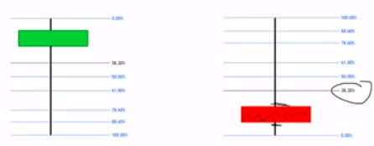

Shooting star.

Similarly for a shooting star i take a fibonacci retracement from the highest wick to the low of the candle or lowest wick and as long as the open and close of the entire candle is below the 38.2 retracement consider that a selling signal or a bearish candlestick pattern similar to a shooting star candle.
What did i change that made them start adding profits to my account that made them start adding higher probabilities to my trading opportunities a little thing called confirmation.

Confirmation:
1. Using a same color candle.
2. It's more accurate if the hammer candle is green but in certain situations i will trade it even if the color of the hammer candle is red.

Entry bullish
1. Hammer green candle followed by another green candle.
2. A good hint that we're at the end of a pullback is the previous level of support during a downtrend or the previous level of resistance before the break.
3. Mark out the previous level of resistance that was broken
4. We would want to see a pullback into this area and our confirmation candles a hammer candle followed by a green candle for a bullish trade.
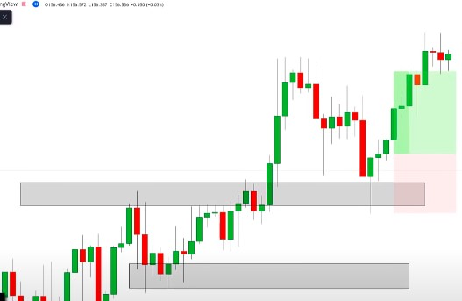
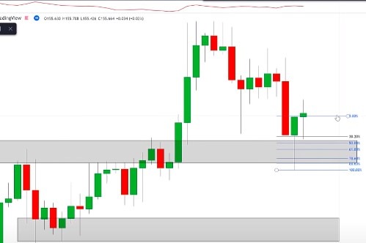
Bearish version Conditions: 1 Hour time frame

1. For a bearish version we're looking for this whole body of this red candle to be below the 38.2 retracement
2. We are looking for a red candle to directly follow.
3. one of my favourite ways to trade this candlestick pattern combination is with the trends.

